Database Design:

Following is the detailed Schema description to the Survey-Wizard, named as Survey_Design:

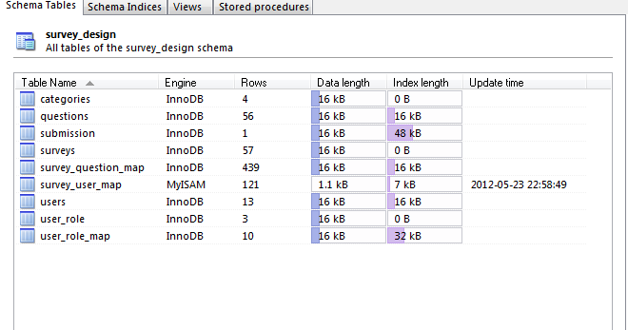

It has the following individual tables for storage of Wizard information:

1) categories- The ‘categories’ table has the following structure:

It specifies the various categories that the Survey Wizard can use.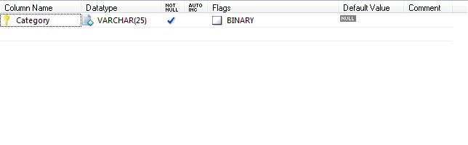

2) Questions- It has the following fields in its structure.

Question_ID is the primary field. This table specifies the structure of Questions used for surveys in the Survey Wizard and provides them each with a unique Question ID. 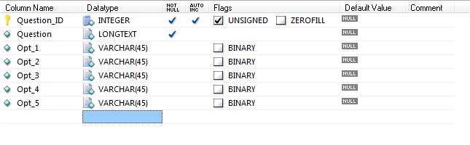

3) Submission- This table has the following structure and has Survey_ID(from the surveys table),Question_ID(from the questions table) and Employee_ID(from the users table) as the foreign key constraints.It specifies a structure for the user response submitted for a survey.

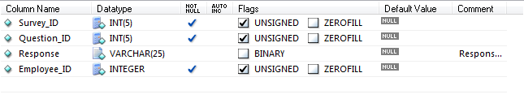

4) Surveys- This table specifies the structure for the various surveys created in the Survey Wizard pertaining to a particular category. Survey_ID is the primary key constraint here.

A special field-‘Flag’ allows to ascertain which surveys are active in the Survey_Wizard and which are not.

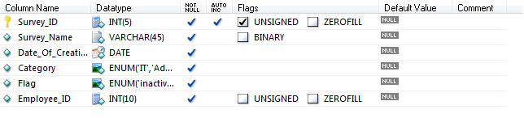

5) Survey_question_map- This table provides mapping facility by mapping questions contained in the questions table to the Surveys in the surveys table. It has Survey_ID and Question_ID as the foreign key constraints corresponding to the fields in the surveys and questions table respectively. A special field- “Flag ”, allows to ascertain which questions in a particular survey from the surveys table are active in Survey Wizard and which are not.

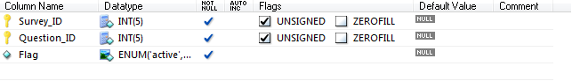

6) Survey_user_map- This table also provides a mapping facility. It maps the user in the users table to the surveys in the surveys table according to the access privileges provided to that user.



7) Users-It is a specification for the users of Survey Wizard.

Employee_ID is the primary key here.

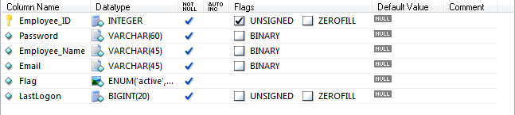

8) User_role- It is table which specifies the various roles that a user in the users table can assume, according to which access privileges are granted to him/her.

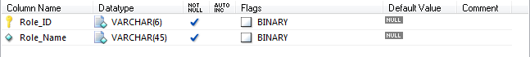

9) User_role_map- This mapping relates the role assumed by a particular user in the users table according to which access privileges are granted to him/her.

